
Madular4 Solutions (Pvt.) Limited.
#76, Pagoda Road, Nugegoda. Sri Lanka.
E-mail: dumindu@modular4.com
Phone: +94 114941921, +94773435429

14th May 2010

Mr. C. Abayagunawardana,
Assistant Manager IT,
Next Finance (Pvt) Ltd.
#61 word Place,
Colombo 7.

Dear Sir,

QUOTATION for "Savings & Real Estate” Management Software Solution

First and foremost, thank you very much for your interest in Modular4 Solutions (Pvt) Ltd. With reference to your inquiry on the above software solution, we are pleased to submit herewith our revised p rice quotation for your kind consideration.

Pricing Summary

Phase 1

Cost of the Savings Management Software Module Rs. 800,000.00

Cost of the Real Estate - Management Software Module Rs. 800,000.00

Total cost of software solution Rs. 1,600,000.00

20% Special Discount For Next Finance Rs. (240,000.00)

Total Value for the Solution Rs. 1,360,000.00

Note:
** MODULAR4 will sell the source code to the client Five (5) times of the Software value on unlimited user license, if client needs.

** Unlimited user license will be provided for each module.

Currency of Offer
All prices are in Sri Lankan Rupees.

Proposal Validity
This proposal is valid for a period of Six (06) month.

Payment Terms & Other Charges

Application System Charges for each Module

50% - on UAT confirmation by user of the GAP Analysis each module
40% - after Implementation of each module (Live run of the each Module)
10% - after Software Warranty Period of each module

Training
User training will be done at site during implementation.

Software Agreement
Software Agreement to be signed with “Modular4 Solutions (Pvt) Ltd.”

Software Warranty
This software solution carries a warranty period of One (01) Year from the date of User acceptance test (UAT).

Software Maintenance
Maintenance services shall be provided under a maintenance agreement to be signed after the warranty period expires. The standard annual maintenance charges would be fifteen percent (12%) on the product price plus the subsequent cost of modifications.

Software Maintenance
Upfront 100% maintenance fees for a period of one year at the signing of the maintenance contract.
During such annual maintenance MODULAR4 shall rectify all software related faults, defects and malfunctions free of charge.

Additional Software Modifications
All additional software modification charges will be quoted after a detailed system study. The development of the modifications would begin once a written confirmation is given by the client.

Modification Charges
50% - on confirmation of the quotation
50% - on implementation of the modifications

Updates/New Modules
Customers under maintenance service agreement are entitled to free Application Updates within the same version, database, operating system, and application language (subject to application customizations done at the client’s site) of the modules purchased.
Other additional/new modules/new version upgrades would be available at a very special discounted price to your company.

Purchase Order & the Payments
Purchase Order and the payments to be issued to “Modular4 Solutions (Pvt) Ltd.”

Some of our clients

Client Name User Reference Solution given

Citygroup Mr. Sumeda Karunarathne PDC – Data Converter Product Manager WHT-Splitter Solution

Printing Solution Ltd. Mr. V Umasudhan Smart Capture & Printing Chief Operating Officer Solution for “Tigo” Billing

Ceylinco Land Exchange Mr. Manjula Suraweera "Water-Billing"
Automation Solution

MBSL Savings Bank Mr. Dushmantha Weerathunga “Pawn – Brokering”
Manager IT Software Solution

Citizen Development Bank Mr. Imdaad Nagiub “Pawn – Brokering”
Manager IT Software Solution

Lake House Printers Mr. Rasika Karandawa “Security Printing”
& Publishers Software Solution

Confidentiality
All material, prices and other information provided in this proposal and other supporting documents, annexure, CD-ROMs, diskettes etc. should not be disclosed to any 3rd party without written consent.

We hope this pricing proposal would meet your requirements. Should you need any further clarifications, please feel free to contact us.

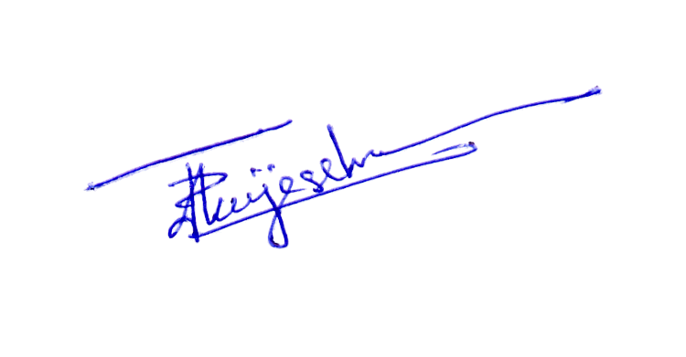
Thank You,
Yours sincerely,

D. Janeendranath Wijesekera
Director Business Development

